Tessella Project Number: 6466
Tessella plc 26 The Quadrant, Abingdon Science Park, Abingdon, Oxfordshire, OX14 3YS, UK
T: +44 (0)1235 555511 | F: +44 (0)1235 553301 | E: info@tessella.com | www.tessella.com

Client: STFC

Mantid
PM report to Project Management Board
16th July 2010



Document Control
This document is under document control. All members of the distribution list will receive updated copies whenever alterations are made. All other copies are uncontrolled.

Contributors
Name | Role | Company
Nicholas Draper | Author | Tessella

Document Approval
Name | Role | Company

Distribution
Name | Role | Company
Project Management Board Members | Recipient | STFC
Mantid Project Repository | Filing | STFC
Notes Projects Database 5951 | Filing | Tessella

Revision History
Author | Issue | Date | Description
Nicholas Draper | V1.R1.M0 | 12-Jul-2010 | 1st version written

References
Document | Ref | Date | Details and Version
Short, Medium and long term requirements from ISIS Instrument groups | [SML REQ]] | 04-Aug-2009 | http://svn.mantidproject.org/mantid/trunk/Documents/Requirements/ShortMedLong%20Aug%2009.xls
Project Specification | [PS] |  | http://svn.mantidproject.org/mantid/trunk/Documents/Project%20Management/ProjectSpecification.doc
Stakeholder Plan | [SP] |  | http://svn.mantidproject.org/mantid/trunk/Documents/Project%20Management/StakeholderPlan.doc
Risk Register | [RR] |  | http://svn.mantidproject.org/mantid/trunk/Documents/Project%20Management/RiskRegister.xls

Table of Contents
1 Introduction 4
1.1 Purpose of this Document 4
1.2 Scope of this Document 4
1.3 Context of this Issue 4
2 Project Status 4
2.1 Development Progress 4
2.2 Project Uptake 7
3 Financial review 9
4 Collaboration with SNS 9
4.1 Current Status 9
5 Future requirements from the Instrument Scientists 9
5.1 ISIS: Requirements in the short, medium and long term 9
5.2 Excitations and single crystal: Visualization and Analysis 10
5.3 SNS 10
6 Supporting Mantid 11
6.1 Current Process 11
6.2 Collaboration support considerations 11
7 Collaborating With Other Facilities 11
7.1 Interest from other institutions 11
8 Resource Planning 11
8.1 Future Release Dates 12
9 Appendix A: Project Financial tracking Spreadsheet 13

Introduction

Purpose of this Document
This report details the current state of the Mantid project and summarises the current plans for further development. The project management board will use the information in this report as a base for the meeting.

Scope of this Document
The scope of this document is limited to the Mantid project, both for progress up to the meeting of the Project management board, and plans for the future.

Context of this Issue
This is the second project management report to the new Mantid project management board and will provide input to the second meeting.

Project Documentation
The project documentation is available through the links below. These documents have now been updated now the Memorandum of Understanding with the SNS has been signed by both parties. There is still a need to define some project milestones centred around SNS/HFIR.
- Project Specification:
http://svn.mantidproject.org/mantid/trunk/Documents/Project%20Management/ProjectSpecification.doc
- Stakeholder Plan:
http://svn.mantidproject.org/mantid/trunk/Documents/Project%20Management/StakeholderPlan.doc
- Risk Register:
http://svn.mantidproject.org/mantid/trunk/Documents/Project%20Management/RiskRegister.xls

Project Status

Development Progress
Since the last PMB meeting in March 2010 we have completed two full iterations and released new versions of Mantid on the following dates:
- 7th April 2010
- 15th June 2010 – 1 Day later than planned, this was delayed to fix and retest a potentially serious stability issue.
The Mantid project continues to progress well. The rate of development within Mantid has remained consistently high and this is backed up by the project metrics in section 3.1.5. In particular we have made significant improvements to (among many others) :
- Implementing or improved over 20 algorithms
- Mantid Help pages – particularly Mantidplot
- Plotting and Instrument Display
- User Preferences ingerated into MantidPlot
- Curve Fitting – Convolution, Instrument Parameters and Automatic Background fitting
- Python Scripting – Autocomplete and parameter tooltips
- SANS and Excitations user interfaces

Development team
ISIS | SNS
Russell Taylor (Tessella, Project Lead) | Stuart Campbell
Martyn Gigg (Tessella) | Peter Peterson
Roman Tolchenov (Tessella) | Janik Zikovsky
Owen Arnold (Tessella) | Mathieu Doucet
Sofia Antony (STFC) | Michael Reuter
Steve Williams (STFC)
Michael Whitty (STFC)
Anders Markvardsen (50%, STFC)
Alex Buts (50%, STFC)
Ronald Fowler (50% eScience)
The development team is working well together. We continue to encourage the knowledge sharing approach we have used up until know though the following mechanisms:
- Monthly developer meetings
- Rotation of developers across different areas of the framework
- Pairing inexperienced developers with mentors when working in ‘new’ areas
Russell will move to the US in August, and join the SNS development team for Mantid.

Development Organisation
The ISIS development team is separated into two teams, a larger core Mantid team, and a smaller subteam concentrating on the visualization and analysis subproject. This separation will is important during the initial prototyping and design phases of this subproject, however as the subproject progresses the teams will naturally integrate more as much of the tools that this team will create will be built as part of the Mantid project.
SNS Team
ISIS
Visualization and Analysis
ISIS
Mantid
Owen Arnold
Alex Buts
Ron Fowler
Peter Peterson
Stuart Campbell
Janik Zikovsky
Matthieu Doucet
Alex Buts
Ron Fowler
Michael Reuter

Russell Taylor
Martyn Gigg
Roman Tolchenov
Sofia Antony
Steve Williams
Michael Whitty Anders Markvardsen
Nick Draper

Since my last visit to the team at the SNS the team has contributed significantly to the project. At present the SNS team are concentrating on tasks that are essential to the completion of quick wins at the SNS site. The team members based at ISIS are providing support and helping the newer team member as necessary in order to smooth their introduction to the project and code base. SNS team members have also contributed several improvements to our build system, and Michael Reuter is helping with some oi the prototyping tasks in the visualization and analysis subproject.
The geographically separated teams but operate well as a single team, communication links have been setup and are actively used across most of the team members. Both the Mantid project and the Visualization and Analysis subprojects have a weekly teleconference to coordinate effort across the team members.

Testing
Automated Testing
The Mantid framework has an extensive test suite of 1,675 automated tests which are run on every code submission by all of the build servers (Windows 32, Windows 64, RHE, Mac OSX). Any failures are immediately emailed to all of the development team ensuring rapid feedback for any side effects their changes might have made. This provides good coverage of the framework itself.
The System Test suite tests users scripts and warns the development team if any change will affect the end results of common scripts.
The current system tests are:
- Powder Diffraction (GEM & WISH)
- Direct Inelastic Convert To Energy
- Polref data reduction
- Data Loading Raw Vs Nexus
- SANS
  - Analysis
  - CentreFinding
  - File summation
  - Batch Opertation
  - Single Period No Trans
- Indirect Inelastic convert to energy

Manual Testing
Over the last three iterations we have followed a different manual testing process than previously. In earlier iterations one or two developers would perform unscripted testing of the application and new functionality for a few days before an official release. This approach was found to be insufficient to really exercise the system, or cover the range of new developments that had been added during development.
Therefore we have moved to get the entire development team involved in the testing of each new release. During the development of iteration as each TRAC ticket is completed it moves onto an awaiting testing list. At the end of each iteration the whole development team, start selecting tickets from this list to test, but they must have not been involved in the development themselves. This approach has several advantages:
- The whole development team have to talk to each other, promoting knowledge sharing
- It encourages developers to think about usability and what the users actually want to do
- Test coverage is much better in breadth and depth
- Robustness of the system is improved, every crash is investigated
- If one or two developers have to spend time fixing urgent issues it does not stop the testing process
- The development team can make the joint call to release, this increases ownership
- The testing process is tracked through the TRAC ticket system.
We have yet to involve both facilities teams in this testing, but this will begin from the next release at the end of August. We need to implement some changes to the TRAC ticket workflow to accommodate this, but we know what to do.

Project Metrics
SubProject | Files | Lines | %comments
Mantid Framework | 1057 (926) | 259,676 (171,235) | 20.4 (25.1)
MantidPlot | 445 (434) | 184,271 (180,165) | 11.2 (11.2)
Total | 1502 (1360) | 443,947 (351,400)
Mantid Framework code has significantly grown since the last PMB (the previous values are in brackets), as would be expected with the addition of new functionality described in section 3.1. The rate of increase to the MantidPlot code is much more limited, but this is to be expected as the code at this level is only concerned with visualisation and interaction, not the processing of the code itself.

Ticket completion rate
Development on Mantid is performed in 6-8 week iterations, each of which ends with an official release of the software. Longer pieces of work sometimes have to span a development iteration in which case that piece of work appears as completed only in the iterations when it becomes available to the users.
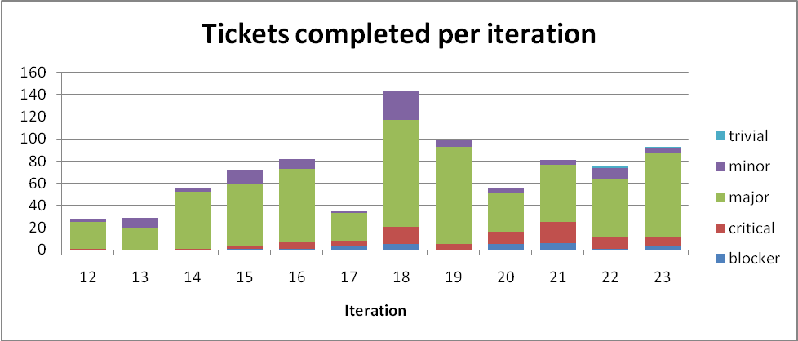
I have restricted the data to the last 12 iterations, with Iteration 22 and 23 being new since the last meeting of the PMB. The completion rate continues to at a good rate, with an increase at iteration 23 being due to ticket completed by staff at the SNS.

Project Uptake

Software Downloads
Our software download site currently requires people to register to a mailing list in order to download the installer packages, this primarily allows us to let users know when a new version is available, but also allow the project to monitor how many people have downloaded the software. A simple analysis of the email domains shows that while the majority of the users are from ISIS, the number of SNS users is rapidly increasing and we have had some interest from other institutions.
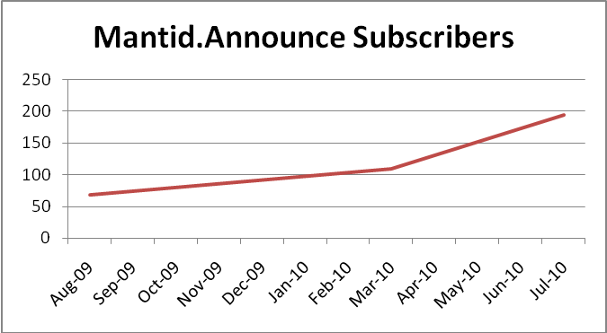
Summary
Date | Users
Aug-09 | 68
Mar-10 | 109
Jul-10 | 195

Current domain breakdown
domain | count
stfc.ac.uk | 72
ornl.gov | 14
gmail.com | 10
helmholtz-berlin.de | 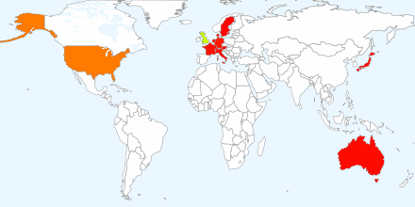  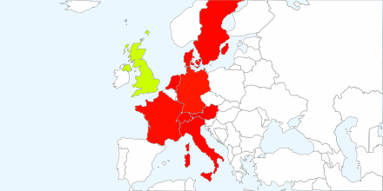  7
anl.gov | 2
ansto.gov.au | 2
bath.ac.uk | 2
chem.ox.ac.uk | 2
ill.fr | 2
owlpic.com | 2
risoe.dtu.dk | 2
sheffield.ac.uk | 2
swansea.ac.uk | 2
uwstout.edu | 2
aber.ac.uk | 1
ati.ac.at | 1
bristol.ac.uk | 1
cea.fr | 1
dur.ac.uk | 1
ed.ac.uk | 1
fysik.uu.se | 1
ill.eu | 1
imperial.ac.uk | 1
isc.cnr.it | 1
jaea.go.jp | 1
j-parc.jp | 1
mcs.anl.gov | 1
paxam.co.uk | 1
ph.tum.de | 1
physics.org | 1
physics.ox.ac.uk | 1
psi.ch | 1
qmul.ac.uk | 1
rri.kyoto-u.ac.jp | 1
shef.ac.uk | 1
sms.ed.ac.uk | 1
space-research.org | 1
surrey.ac.uk | 1
thorsbro.dk | 1
tudelft.nl | 1
uea.ac.uk | 1
unimelb.edu.au | 1
warwick.ac.uk | 1

Instrument usage

WISH
Mantid is now in use supporting all of the data reduction for powder diffraction on WISH, and the python scripting capability is being widely used to provide flexibility in analysis and to help support the large memory requirements of WISH data.
While the majority of powder diffraction data reduction is now supported for Mantid there are areas to further improve the software. These are primarily centred around improving the details of the Absorption correction to take into account the beam divergence and multiple scattering.
Currently WISH does not have any software to support single crystal data reduction and analysis, this is planned to be included within Mantid over the next 10 months.

GEM
Mantid is now providing all of the data reduction for HRPD.

HRPD
Mantid is now providing all of the data reduction for HRPD.

SANS2D
Mantid is supporting all of the data reduction needs of SANS2D. Recent improvements have allowed support for multi period data analysis, and experimental data captured on previous cycles to be analysed where it was previously not possible.

LOQ
Mantid can to supporting all of the functionality of collette. The decommissioning of collette will be considered during the long shutdown of ISIS.

OFFSPEC
Data reduction on OffSpec is now exclusively carried out using Mantid. Python scripts exist for the majority of functionality that was previously achieved through the use of both OpenGENIE and Matlab. Users appear to be comfortable with the current system and have been able to rapidly learn and use the various components.
The most recent development makes use of Python Algorithms to provide users with command line syntax hints for all the commonly used commands.
In addition a simple reflection gui has been developed for OffSpec which produces automated plots. This has not yet been incorporated into the main code base but could quickly be included after agreement with the rest of the reflectometry group.
In the coming months the Large Scale Structures group plan to implement a group wide code base that will allow the same data reduction scripts to be used on all five of the ISIS reflectometers. Tim Charlton will co-ordinate this effort with the eventual goal being to incorporate the code into the publically available release.

EXED (HMI)
Mantid is supporting the Data reduction needs of EXED at the HMI in Berlin.

Supporting Mantid

Current Process
In order to provide support to our users we have created a specific help email address mantid-help@mantidproject.org. All emails to this address are forwarded to the a restricted support team within the project; normally it is the responsibility of the Project Manager to assess the request and assign it to the most appropriate member of the team, but other members of the team can act on request should the project Manager not be available. The support team will not answer every request themselves, but will ensure that every request is answered. The support team comprises of:
- Nick Draper
- Russell Taylor
- Stuart Campbell
- Martyn Gigg
We have not held any further sessions of our Python or Mantid scripting training courses since the last PMB meeting. In association with recent developments allowing algorithms to be developed in Python we plan on extending the range of courses with another ½ day course on how to write python algorithms.

Financial review
Details of the project financial state are included in Appendix A. The current order with Tessella will end at the start of April 2011. The current contract will fall short of this target date by roughly one month, this shortfall will need to be addressed. One possibility is for the SNS to fund a proportion of the Project Management effort of the Mantid project.

Collaboration with SNS

Current Status

Memorandum of Understanding
This has been agreed and signed by both parties.

Permission to contribute to an Open Source Project
This is cleared as far as the Mantid project is concerned.

Future requirements from the Instrument Scientists

ISIS: Requirements in the short, medium and long term
In August 2009 we conducted a requirements gathering exercise where we asked each of the groups present at the scientific steering committee to submit their requirements for Mantid over the following periods:
- Short: up to six months – Ending Feb 2010
These have now all been completed
- Medium: up to 18 months – Ending Feb 2011
Progress is being made on the following aspects:
  - Excitations: Full conversion of Homer, integration with Visualization and Analysis subproject
  - Indirect: Cylinder and Flat plate Absorption corrections
  - Muon: Replacement of UDA functionality, Alpha Estimation, Variable Binning, Fit parameter linking and constraints
  - Reflectometers: SVN Repository of scripts / Algorithms that is easily updateable, Robust and flexible core algorithms
  - SANS: Show instrument to update real time with LoadDAE, Batch Processing
  - Crystalography: Visualization of Very Large datasets
  - Scientific Computing: Windows 7 Support
- Long: 18 to 36 months – Ending Aug 2012
  - Several: MC absorption correction with Multiple scattering
  - Excitations: Distributed computing graphics
  - Scientific Computing: Event based data support
The spreadsheet is available in the link below.
http://svn.mantidproject.org/mantid/trunk/Documents/Requirements/ShortMedLong%20Aug%2009.xls

Excitations and single crystal: Visualization and Analysis
This subproject is underway, The requirements document has been written and reviewed. Work is now progressing on prototyping the more challenging aspects of the project and evaluating third party technologies for visualisation and distributed job submission. The project plan below has been updated with progress to date.
http://svn.mantidproject.org/mantid/trunk/Documents/Project%20Management/Visualisation&Analysis/Mantid%20Visualizations%20project%20plan.pdf

SNS
The initial quick wins SNS have been identified where existing support within Mantid can rapidly be reused at the SNS have been defined, these are:
- Powder Diffraction
- Direct Inelastic
- Small angle neutron scattering
In order to implement these for use at the SNS there are a variety of tasks that have been identified and created as tickets in the TRAC system, broadly they fall into the following categories:
- Loading of SNS data file formats
- Storing and processing Event based data
- Implementing instrument definitions for SNS and HFIR instruments
- Handling local differences in data analysis, script generation
- Small angle adjustments for reactor based instruments

Resource Planning
At present the effort is split across the group in these proportions:
Task | Effort (FTE)
Support | 0.8
Framework development | 1
Project Management | 1
Project Support | 0.1
User interface development | 1.1
Crystallography | 0.3
Small Angle | 0.4
Reflectomoters | 0.2
Disordered Materials | 0
Muon | 0.2
Excitations | 1
Molecular Science | 0.4

Future Release Dates
The planned release dates for the rest of this year are:
- 31st August 2010
- 29th October 2010
- 20th December 2010

Possible Collaborating With Other Facilities

Interest from other institutions

Reactor Sources

ILL
As a follow up to the visit of Andrew Harrison and Mark Johnson visited us on the 3rd February, they have contacted us to let us know they will be recruiting someone later this year to perform a 6 month evaluation of Mantid.

LLB
During a recent visit Rob Dalgleish introduced Frederik Ott to Mantid, he is having a look into Mantid as an option to Analyse reflectivity data. Also Christian Alba-Simionesco (an LLB director) has been in touch with Robert McGreevey about collaborating on TOF SANS and reflectonetry data

ANSTO
Nick Hauser visited ISIS recently and discussed Mantid. They are expanding their number of beamlines significantly, and are already struggling to support the range of data analysis codes already in use. Nick asked about other reactor sources, and I mentioned HFIR and ILL. He said that if ILL were to use Mantid they would probably do so as well.

Pulsed Neutron sources

J-Parc
Masa Arai has previously expressed his interest in Mantid.

ESS
Christian Vettier is interested about using Mantid for the data reduction / analysis. He would like some people from the Data Management Centre in Copenhagen to come and visit to learn more about us. This is still somewhat in the future and there is little point arranging a visit before the Head of the Data Management Centre is recruited.

Appendix A: Project Financial tracking Spreadsheet

 | (Values excl VAT inc Expenses)
 |  |  | Mantid (6466) - Mantid CATALIST 2010
 |  |  |  |  |  | Prediction
 |  |  | Orders | Invoices | Exp | Days | Invoice | Staff | Rate |  | Orders | 260,000.00
invoice for | Month | Order | 260,000.00 |  |  |  |  |  |  |  | Spent to date | 15882
Jun-10 | 1 | Jun-10 |  | 15882 |  | 16 | £15,882.00 | 5 | £293.26 |  | Order Cover | 244,118.00
Jul-10 | 2 |  |  |  |  | 15 | £32,991.75 | 5 | £293.26 |  | Hours left | 832.43
Aug-10 | 3 |  |  |  |  | 18 | £32,032.80 | 4 | £237.28 |  | Days left | 110.99
Sep-10 | 4 |  |  |  |  | 16 | £28,473.60 | 4 | £237.28
Oct-10 | 5 |  |  |  |  | 15 | £26,694.00 | 4 | £237.28 |  | Total Rate | £293.26
Nov-10 | 6 |  |  |  |  | 18 | £32,032.80 | 4 | £237.28 |  | DRAN Rate | 0
Dec-10 | 7 |  |  |  |  | 18 | £32,032.80 | 4 | £237.28 |  | TOLR Rate | 0
Jan-11 | 8 |  |  |  |  | 16 | £28,473.60 | 4 | £237.28 |  | GIGM Rate | 0
Feb-11 | 9 |  |  |  |  | 18 | £32,032.80 | 4 | £237.28 |  | ARNOW rate | 0
Mar-11 | 10 |  |  |  |  | 17 | £30,253.20 | 4 | £237.28 |  | TAYR Rate | 0
 |  |  |  |  |  |  |  |  |  |  | Last complete month | 31/01/2011
 |  |  |  |  |  |  |  |  |  |  | Final month cover | 31386.65
 |  | Totals | 260,000.00 | 15882 | 0 | 167 | 290899.35 | 4.2 |  |  | End Date | 23/02/2011

